# Manage placements blacklist

1.Open [Kibana](https://esadsquality-kibanaslc.vip.ebay.com/app/kibana) and click 'Dev Tools'

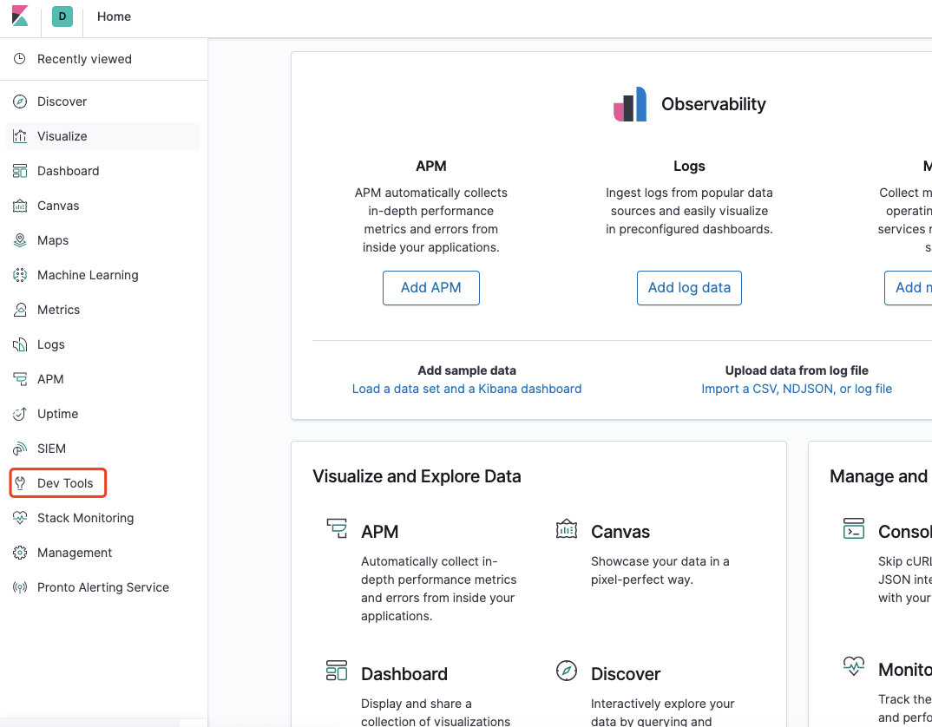

2. add one placement

POST /alert_black_placement/_doc  
{  
"placement":"101113",  
"suppress_time":1000,  
"update_ts": 1627874718  
}

3. update one placement

POST /alert_black_placement/_update/FNk2BXsBDT3NIBVQ7lJf  
{  
"doc": {  
"placement": "101113",  
"suppress_time" : -1,  
"update_ts": 1627873718   
}  
}

TIPS:

suppress_time(seconds):

* -1, permanent suppress
* placement will be suppressed from update_ts to update_ts + suppress_time